Palmer Park Geology Field Trip
Saturday MARCH 14th, 2020
10:00AM to 12:00PM
For: All sections of Geology taught by Professor Mark Izold
Where - We will meet at Picnic/Group marked Council Grounds Picnic Area. From Academy take Maizeland Road to the west for about ¼ mile. Go north about 1/3 mile and turn LEFT into picnic/group area (Council Grounds Picnic Area). Follow the DIRT road for about 1/3 mile until it ends in a parking area with a ponderosa pine tree in the middle.

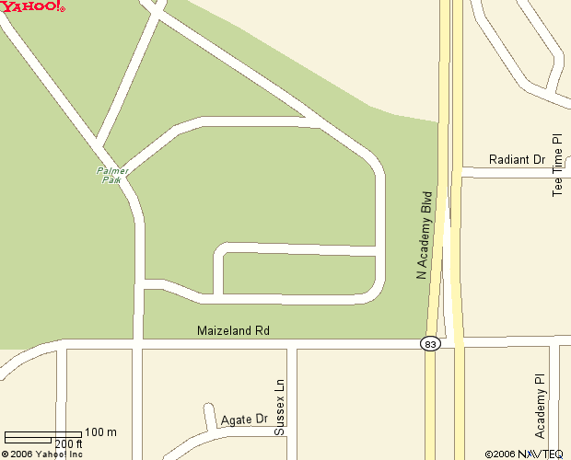
“Council Grounds Picnic Area”
Pine tree in middle of cul de sac, at the end of the gravel road.
Latitude: 37.871266
Longitude:-104.76687
Latitude: 38.871109
Longitude: -104.767087
Dog walk area
NORTH
Shell
Station

*Please note there is no disability access for this portion of the park. A bit of “rock scrambling is required. So dress appropriately.” Thanks!
Geology Information – Palmer Park Field Trip

Dawson Arkose – Transitional from Cretaceous to Tertiary, the Dawson Arkose represents a tropical rainforest deposit. Sediments found in the Dawson Arkose were derived from the Laramide Orogeny, or “Rocky Mountain” uplift which began about 65 million years ago. This formation extends across the Cretaceous/Tertiary boundary (aka. K/T Boundary.)

Sediment & Sedimentary Structures:
Graded bedding – Large clasts at the base of a sediment sequence which fine upward to smaller particles, this is indicative of flooding events.
Cross bedding- Layers deposited at an angle by wind or water. In this case, the banks of a stream.
Sorting- A medium such as water or wind can divide particles or carry all particle sizes based on energy of flow. Poorly sorted pertains to particles of all sizes. Well sorted indicates that one sediment size is predominant. This indicates the strength of paleo-currents.
Rounding- This indicates the degree to which a sediment has been transported. Angular sediments have not traveled as far as rounded particles.
Maturity – This can refer to texture (rounded versus angular) and chemical composition (silica rich versus clay rich). Minerals which are chemically “untouched” have been transported over minimal distances, these are proximal to the source.
Soft Sediment Deformation:
- Convolute Bedding (aka. soft sediment deformation) – Uneven bedding caused by competent beds overlying weak water-logged fine sediments.
- Flame structures – Sediments which are injected into overlying layers due to water content. These are related to convolute bedding but are more pronounced.
Paleoenvironment:
- Alluvial Fan deposits: When flat topography is adjacent to mountainous topography. The sudden change in topography causes a stream to deposit its sediment load.

- Floodplain – Area adjacent to an old age stream that receives the over flow from a stream that has exceeded its capacity.

- Crevasse splay deposits – A natural levee breach that forms a deltaic deposit adjacent to a stream.

Fossil Preservation Types:
- Mold-Cast: Internal and external impressions of a fossil.
- Carbonization: The carbonized film of plant or animal.
- Araucaria sp. – Tropical conifer related to the Norfolk pine, common in the Cretaceous.

Cementing Agents and sedimentary rock “staining:”
- Siderite – Iron carbonate
- Hematite – Red to re-brown iron-oxide.
- Limonite – Yellow to yellow brown iron-oxide
- Goethite – Dark brown iron oxide.
NOTE: Collectively these are known as FeO_{x} minerals and are different oxidation states formed by different pH and eH of groundwater that has moved through the rock material prior to exposure. A rock layer can contain different cementing agents based on mineral content and conditions of the groundwater.

Additional Information:
Castlewood Canyon
http://www.parks.state.co.us/Parks/CastlewoodCanyon/Publications/Documents/065884181cb34777a33009eb95f9b1a7CastlewoodGeology.pdf
Ancient Denver (and other Geology along the Front Range)
http://www.dmns.org/main/minisites/ancientdenvers/park.html
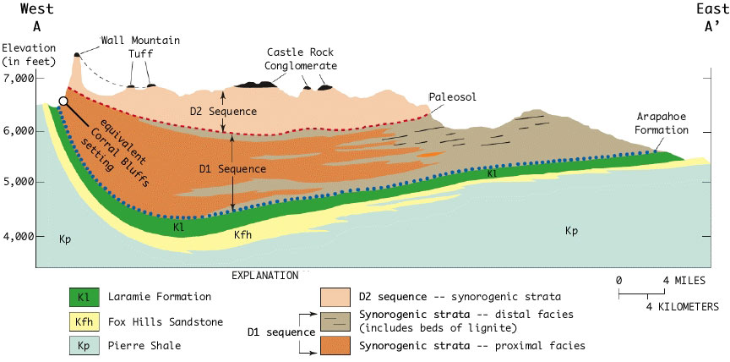
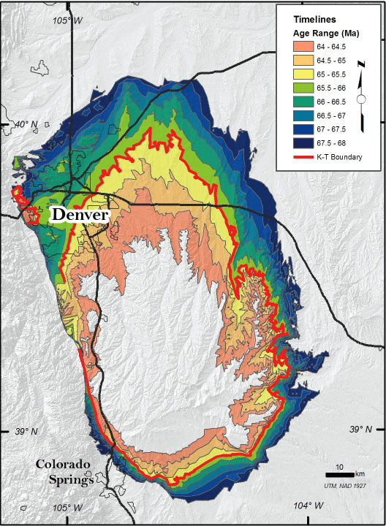

Palmer Park

“Simple” Stratigraphic Column from Save Corral Bluffs Web Site:
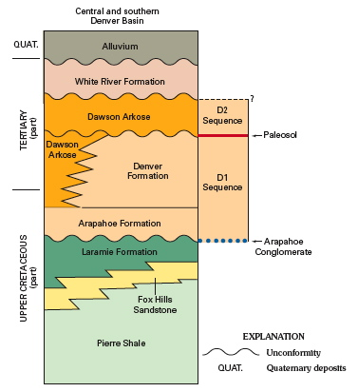

Calhan, CO – Paint Mines
Palmer Park

